Homework 0

CS 6515 – Introduction to Graduate Algorithms

**Problem 1**: See answers on PDF (Check Joves notes for explanations)

**Problem 2:**

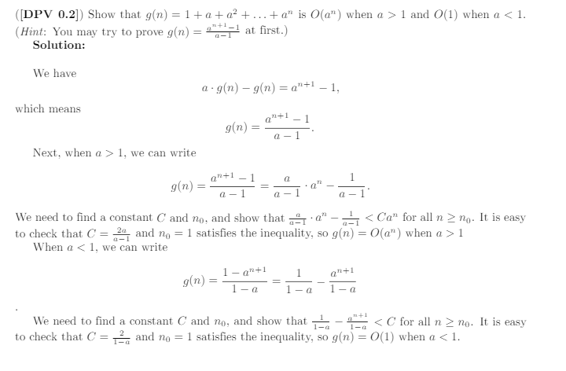

**Problem 3:**

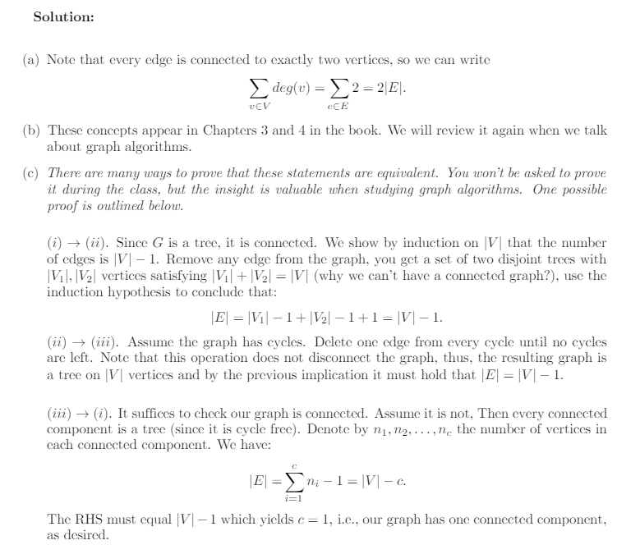

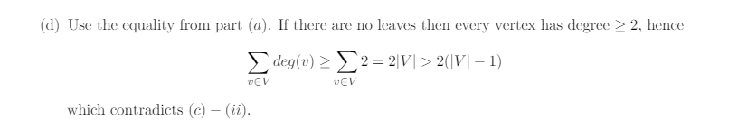

**Problem 4:**

